First Nature Ranch Volunteer Handbook

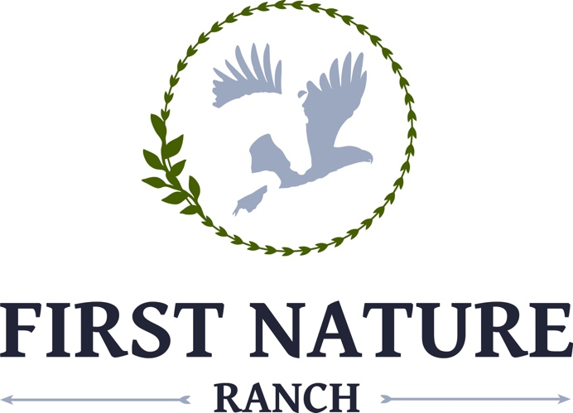

General Volunteer Information

Prior to service, all volunteers must complete all forms deemed necessary by First Nature Ranch, complete a background check, and undergo orientation.

What do volunteers do?

The welfare of our animals is a top priority at First Nature Ranch. Volunteers can help care for the horses by:

▪ Scrubbing buckets and troughs ▪ Collecting manure    
▪ Grooming and tacking ▪ General barn chores

Volunteers also help with maintenance of our facility so it’s safe for our horses and in top shape for people by:

▪ Cleaning pastures ▪ Cleaning/polishing horse tack ▪ Sweeping sheds and barn areas ▪ Maintaining overall cleanliness    
▪ Moving light equipment ▪ Other general light facility maintenance

Facilitator Assistant for playshops, classes, and clinics: Though this volunteer position may seem unimportant, it is VITAL to our participants. Your primary responsibility is the participant, their safety, and horse safety. Some of your responsibilities include:

* Directing participants within facility grounds
* Acting as the facilitator’s aid during playshops
* Following the facilitator’s directions during a playshop and assisting the participant only when asked

Horse leader: This position requires previous horse experience and cannot be performed by all volunteers. Your focus is to be on the horse, not the student or participant. Responsibilities include:

* Bringing horses into and out of facilitation areas
* Maintaining a partnership and leadership stance with the horse at all times
* Understanding the horse’s body language
* Monitoring the horse’s breathing, soundness, and overall disposition
* Bringing any concerns about the horse’s welfare up to a staff member

Volunteer Captain: These are volunteers that have been serving the organization for years and/or that show a great amount of responsibility and horse knowledge may be promoted to volunteer captain. These chosen individuals have many responsibilities such as training new volunteers, assisting in orientations, and helping recruit new volunteers.

First Nature Ranch relies deeply on volunteers for multiple different tasks. If you have any special skills, interests, or hobbies, please let us know. Here are a few other volunteer opportunities we have available:

* Special event planning and staffing
* Fundraising
* Grant writing
* Promotional/marketing activities
* Office work (filing papers, sending emails, stuffing envelopes, etc.)
* Photography or videography
* Entertainment
* Legal support

What you should expect:

* To have fun
* To learn
* To feel needed
* To be outside in the heat (and sometimes cold)
* To get dirty
* To make a BIG difference in peoples’ lives
* To make mistakes and to learn from them
* To love and be loved

Your Commitment

Our mission relies heavily on dependable volunteers; they are an essential part in our day-to-day operations. Our students and participants cannot have a good experience unless the we are adequately staffed. In order to assure that we are giving everyone a good experience, volunteers must be willing to commit to the positions they sign up for.

We understand that illnesses or other conflicts can occur and may prevent you from being able to serve. If that situation arises, please contact the volunteer coordinator at least 24 hours before scheduled assignment so that a substitute can be found. We depend on our volunteers to show up for their shifts to help us with our work at the ranch, and have had to institute a policy that if a volunteer doesn’t show up for a shift without 24 hours notice more than twice in a 4 month period, they lose their volunteer privileges and must reapply for the role after 3 months.

WE REQUIRE THAT ALL CELL PHONES BE ON SILENT OR TURNED OFF WHILE AT THE BARN DUE TO THE POSSIBILITY OF STARTLING A HORSE OR DISTRACTING STUDENTS, PARTICIPANTS, AND INSTRUCTORS. THEY ARE NOT TO BE USED AT ANY TIME DURING A PLAYSHOP OR LESSON.

Volunteer Training and Guidelines

Each volunteer will attend a mandatory orientation that covers the following:

* Facility layout- to include restroom location, parking, tack room, feed room, and first aid kits (human and equine)
* Emergency procedures
* Introduction of staff, both human and equine
* Emergency phone number and contact information

What to Wear:

* Be aware you will be doing a lot of walking on multiple surfaces, including but not limited to, loose sand, muck, and long grass. If/when a horse steps on your foot, it DOES hurt. Comfortable, supportive, yet sturdy shoes are very important. No open toe or open heel shoes are allowed at the barn. Boots are recommended.
* We all know that is gets VERY hot here in Florida. Loose, light colored clothing is optimal during the summer. We encourage you to wear your First Nature Foundation shirt. Please be sure you appear neat, clean, and respectfully/appropriately attired.
* Modest shorts and t-shirts are acceptable in the summer and we suggest layers in the winter. Very short shorts are not permitted. Please wear a neat, modest shirt.
* A hat, sunglasses, reusable water bottle, and sunscreen are all highly recommended. Don’t forget a rain jacket for those summer afternoon storms!
* Long hair should be tied back and please avoid wearing dangling earrings, necklaces, and bracelets that could get caught on anything. We ask that you also not wear heavy perfumes, colognes, or hairsprays.
* Please realize that you are a representative of our organization to the community and dress appropriately.

What NOT to wear:

* Bare midriff or other revealing clothing
* Open toe shoes, sandals, or clogs
* Clothing with offensive/inappropriate slogans, words, decals, etc.

Many volunteers at FNR are teenagers or young adults that are experiencing responsibility for their first time. To help set them up for success, here are some things we value in our volunteers and that will help in all aspects of one’s life.

* Punctuality- The staff and students are FNR are counting on our volunteers to be there. If they do not show up, our students can’t ride. Please be on time and be sure to sign in and out.
* Attitude- **Please avoid gossip**. We recommend that you do not repeat any sensitive information unless the person you tell can help the situation. If you have a concern or need to have something explained in more detail, SPEAK UP. Ask questions, set up a meeting with the Manager of Volunteer Services or any other staff member you feel comfortable talking to. Please take initiative and take pride in your work. Look for jobs that need to be done around the barn and be a great example for others.
* Performance- We understand that a lot of our volunteers have a significant amount of horse experience, but please leave the riding instruction to the instructor. Avoid chatting with the students during a lesson or participants during a playshop because it can be very distracting. Follow all rules and policies at all times.

We encourage you to spend as much time as you want at the barn but, please, do not get burned out!

The staff understands that you have a life outside the barn.

A particularly gifted volunteer might be asked to help out a lot, and we don’t want anyone to feel overwhelmed or feel resentment towards us. If you need a break, please don’t feel guilty about saying “NO.”

**Inclement Weather**

• There might be times we have to cancel lessons due to bad weather. If unsure, please call the Volunteer Coordinator.

• In the case of an impending hurricane, volunteers may be asked to help secure the barn and/or relocate the horses in the days or hours leading up to the storm’s arrival.

**Logging Your Hours**

* It is very important to us that we track all volunteer hours.
* Signing in and out using the JoinHomeBase app is vital to our fundraising efforts and recognizing volunteers for all their hard work!

**Confidentiality**

* While some students may be open about their disability, medical history, or personal challenges, remember you make an Oath of Confidentiality when you started your service with First Nature Ranch.
* During a class or therapy session, you might be told information about a student in order to safely and effectively assist them. This information is confidential and should never be repeated.
* If you hear something that makes you feel uncomfortable, please talk with a staff member right away.

**General Procedures**

• All doors/gates must be closed at all times, with the exception of the tack room, bathroom, and office. This includes arena gate and stall doors.

* Turn off lights and/or fans when not in use.
* Place all items back in their correctly labeled spots.
* Volunteers are permitted to leave food items in a horse’s bucket.
* Do not play with or around the horses’ mouths.
* No more than 2 volunteers should be in a stall with a horse at any time.
* Outside a stall or arena a horse must never be lead without a lead rope and halter or bridle and reins.
* Only volunteer captains and staff members are to put on or remove bridles until you can show competency.
* Volunteers are not permitted to drive any company vehicle unless given express permission by the manager.
* Any illness, injury, or out of the norm occurrence must be reported immediately to a staff member and an incident report must be filled out.

**Stall Cleaning**

* Take care when cleaning a stall while a horse is still in it if a staff member is unavailable, or wait for a staff member to clean the stall.
* Remove all feces and dilute and sweep out any urine.
* Check the water bucket to make sure it is clean and full.
* Place all equipment back in designated locations when completed.

**Dismissal of Volunteers**

If any volunteer should infringe on any of First Nature Ranch rules or if their performance is unsatisfactory, disciplinary actions will be taken to correct any further occurrence. The procedure is as follows:

1. Verbal Warning

2. Written Warning

3. Suspension

4. Termination

**Gross Misconduct**

* Gross misconduct is a volunteer’s behavior that warrants immediate termination without   
  following the steps mentioned above. Some examples of this behavior include:
* Violent outbursts
* Abuse, neglect, or exploitation of students, staff, or other volunteers
* Committing a crime while at First Nature Ranch
* Extreme insubordination

Safety Protocols and Procedures

Safety is our number one priority, for both humans and animals. Please read the protocols below carefully and do not hesitate to ask questions!!

**Loose Horse Protocol**

* Remember human safety comes first!
* If the loose horse is located within the fencing and is approachable, walk calmly towards the animal with a halter, lead rope, and bucket with a small amount of grain.
* If possible, attach the lead rope onto the horse’s halter and secure him or her in a stall.
* If the horse is excited or stressed or you are unable to catch the animal, please find or call a staff member for assistance. Do NOT run/chase after the horse!
* If the horse is located outside the fences of our facility, please contact a staff member immediately.

**Loss of Power**

In the unlikely circumstance of the barn or arena being without lights, please follow these procedures:

* Stay where you are and remain calm
* If you are in the arena during a lesson, follow the instructor’s directions
* Staff will distribute flashlights or source of light and car headlights may be used

**Fire Protocol**

Upon ANY indication of a fire in progress, call 911 and notify a staff member. The phone is located on the desk in the office and of course you may use your personal cell phone.  
If you see a fire in the beginning stage (first flames, or initial spark) and you feel capable of extinguishing the fire, retrieve the nearest fire extinguisher and proceed to put it out. The fire department should be notified that the initial fire has been handled, but requested to come inspect the area to ensure it has been completely extinguished.

ALL individuals should proceed in an orderly fashion to the outdoor arena via the nearest exit without going through the barn if at all possible.

Staff and facilitators are responsible for indicating the direction of the nearest exit and seeing that all students and volunteers immediately exit and quickly proceed to the outdoor arena.

• If there is a lesson/playshop/class/clinic in progress in the outdoor arena, the clients will be evacuated and horses left in the arena.

* Each staff member shall perform a headcount of students and volunteers upon arriving at the outdoor arena. Because of this, no one is allowed to leave the property during a fire evacuation unless there is a life-threatening need.
* A senior staff member shall take charge of the meeting area. Their responsibilities are:
  1. Determine from instructors and others any persons unaccounted for.
  2. Establish that the fire department has been contacted. If not, a designated person will be sent to the nearest safe phone.
  3. Arrange for First Aid or emergency medical needs of any person(s).

1. Know the whereabouts of any staff members that have returned to the building or are on errands.
2. No one shall reenter the building unless given permission by the senior staff member. The only reason to reenter the building is to assist clients in evacuating the building. Persons who reenter to assist in evacuation should do so in pairs and should NOT enter an area where smoke impedes vision. At staff discretion, horses that can be removed while exiting, without endangering the evacuation of persons, and may be taken to pasture or outdoor arena and turned loose.
3. Should circumstances make any of these procedures impractical (i.e., wind conditions, location of fire) the senior staff member shall make necessary modifications.
4. Fire extinguishers are located in the office, kitchen, and feedroom inside the barn and in the feed/tack shed. Fire extinguishers are inspected annually and recharged when necessary. All staff shall be instructed in the use of fire extinguishers.

**What to do in the event of a human injury or emergency**

1. Stay Calm: The worst thing you can do in any emergency medical situation is panic. For the sake of the victim and other volunteers, try to remain calm, cool, and collected. You will be more effective and efficient this way.
2. Assess the Situation: Quickly assess the scope of the injuries and collect information. If an injured person is conscious, ask her to tell you if anything hurts and observe where on their body they may be physically injured. Do not move an injured person, especially if they are reporting pain, unless there is imminent danger.
3. Call 911: If a person is badly injured, call 911 immediately. If there is any doubt as to whether emergency services are needed, it is better to be safe than sorry. Stay calm and provide your address, location in the building, phone number, name and any information you have gathered about the injuries (most of this information can be found above the phone in the office).
4. Administer First Aid and CPR: If required, CPR or first aid should be performed by a person who is trained to do so. If there is no skilled person, wait for emergency professionals. Do not administer medical attention or medications. Be careful not to come in contact with blood, vomit, or other bodily fluids.

**What to do in the event of a tornado:**

* Remain calm
* Follow staff’s directions
* Be prepared to evacuate the arena
* Make your way to a solid building and you may be required to assist students or other personnel to safety
* Please remember human safety is our number one concern and depending on the severity of the weather, horses may or may not be evacuated

Understanding Our Equine Partner

First Nature Ranch trained horses are still horses and thus have natural instincts. They have undergone specialized training to be able to handle the added stresses of their work.

Horses, by nature, are a prey animal. This means they have a strong “fight or flight” instinct. Having a fight or flight response means that if an animal is unsure about something, they will either to try flee (flight) or protect themselves via kicking, biting, etc. (fighting).

Please take care to not spend time around the horses’ head. The best way to approach a horse is from the side, near their neck. All animals have the potential to bite, including our horses.

Glossary of Equine Terminology

Aids: signals the rider uses to control the speed and direction of the horse.

Canter: natural gait possessed by all horses, faster than most horses' trot but slower than the gallop.

Figure Eight: a schooling figure that consists of two connecting circles.

Gelding: castrated, adult male horse.

Hands: a height measurement for horses. A hand is four inches. To find a horses’ height, you would measure from the ground to their withers.

Half circle reverse: During a lesson, a movement used to change direction.

Horse: the term used to describe an equine that is taller than 14.2 hands.

Inside leg/side: the leg on the inside of the ring, usually the side that the instructor is on Mare: adult, female horse.

Near side: the left side of the horse (when mounted). A horse is always mounted from this side.

Off side: the right side of the horse, see above.

Outside leg: the rider’s leg on the outside of the ring.

Pony: the term used to describe a full-grown equine that is shorter than 14.2 hands.

Serpentine: a series of circles and straight lines crossing from one side of the ring to the other; a schooling exercise.

Stallion: adult male horse that has not been castrated.

Trot: the pace at which a horse moves that is faster than a walk but slower than a canter; diagonal pairs of legs move forward together.

Equine Anatomy

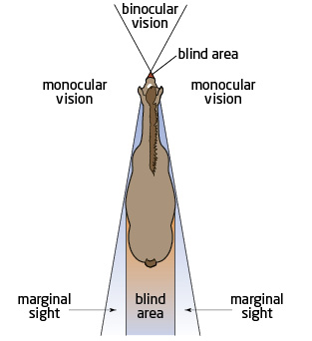

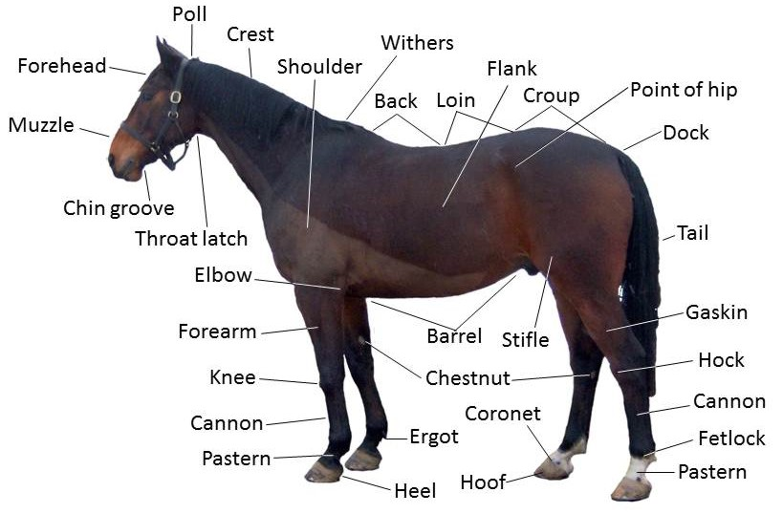

Frequently Asked Questions

1. What are the qualifications to be a volunteer?
   * Must be at least 14 years old
   * Must speak English
   * Be able to walk or stand for longer periods of time if wanting to assist with playshops, classes, and clinics
   * Ability to accept supervision and guidance
2. When do volunteers get to ride?

We offer “Volunteer Reward Events” once per month when our horsemanship instructor is at the ranch. These sessions act as a chance for our volunteers to get more ground skills and even get in the saddle as well as a hands-on, continuing education experience.

1. I signed up to help with a lesson, but now I can’t make it. What do I do?

If you need to cancel more than 24 hours before the lesson, contact The Volunteer Coordinator via email or text. If the lesson is less than 24 hours away, please contact The Volunteer Coordinator directly by either phone or text.

1. I left my sweater, hat, keys, etc., at the barn. Where can I find them?

Any items found to be left behind will be placed in the ‘Lost and Found’ bin located in the tack room.

1. What do I wear to the barn?

Depending on the climate, please wear neat, yet comfortable clothes. If you have obtained a Volunteer t-shirt, please wear that. Closed toe and heal shoes are mandatory and we suggest a hat, sunglasses, and sunscreen.

1. I am volunteering to get credit for school. What do I do?

If your school has a form or letter that needs to be signed, please bring it with you to the barn. Our Volunteer Coordinator will be more than happy to sign it for you. If your school requires documentation but does not provide a form, the Volunteer Coordinator will be more than happy to write a letter to your school confirming your volunteer work.

1. Where do the horses come from?

Very rarely are the horses purchased for First Nature Ranch, but instead most are donated from a variety of sources. It takes a very special equine to be one of our horses, so not all horses make the cut. Any time a horse is donated to us, it goes through a trial period, usually lasting about 90 – 180 days. During this time, the horse is evaluated on multiple levels for things such as temperament, manners, ability to accept different and/or challenging situations and riders, coping with side walkers, etc.

1. What do we do if we show up to the barn and aren’t scheduled in a lesson?

Just because you aren’t scheduled doesn’t mean we don’t need you! There is always something that needs to be done around the barn- cleaning stalls, bathing horses, scrubbing buckets. There is a list of chores located in the tack room.

1. Where can I put my phone, keys, purse, etc.?

The best place for a phone and purse would be safely in your car. If your keys don’t fit in your pocket, feel free to tuck them in the tack room somewhere. Please note, this area is not locked and thus not guaranteed safe! We request you do *not* use the barn office to store your items.

10. How do I sign up to help?

• Please complete the volunteer application form found online and bring it to the Volunteer Coordinator or Manager or scan and email it to [info@firstnaturefoundation.org](mailto:info@firstnaturefoundation.org)

If you have any questions, please feel free to ask the Volunteer Coordinator at any time.